**SLCP Meeting 7/15/2021**

**Moderators:**

Lisa Kropp and Annemarie Gordon

**Note Taking:**

Annemarie Gordon

**Attendance:**

Sara Fiorenzo (Lindenhurst), Jen Ferriss (Saratoga Springs Public Library), Jeri Cohen (Patchogue-Medford Library), Erick Frank (Brentwood, East Islip), Claire Mitchell (School Librarian, Massapequa School District), Courtney Tsahalis (Millbrook Library), Sarah Matthews (Harborfields Public Library), Rebekkah Smith Aldrich (Co-Founder SLI, Mid-Hudson Library System), Debbie Bush (Comsewogue)

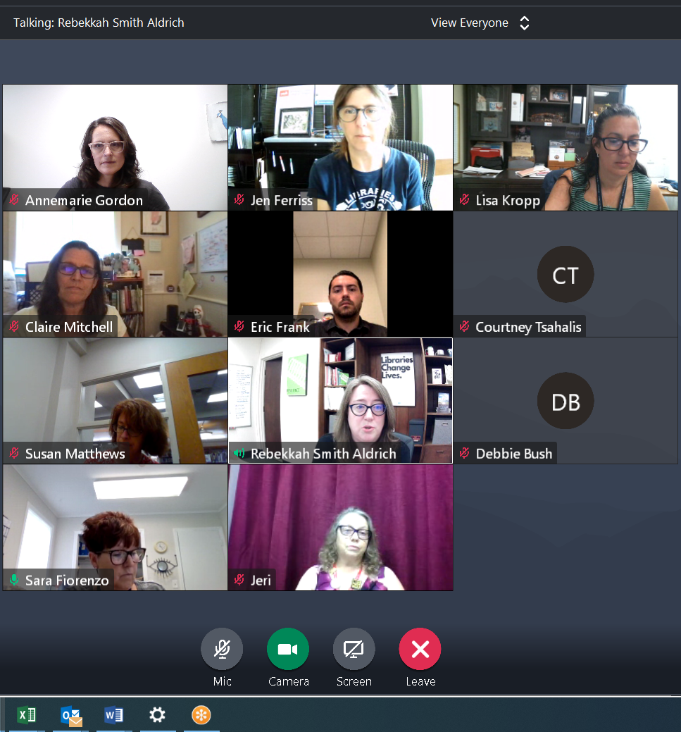

**Notes:**

Introductions, reports and questions:

Annemarie - introduction

Sara - New title of Sustainability Coordinator. Report on community garden harvest deliveries to community organizations. Sustainable programming including: repair cafes, beach cleanups, working with [Save the Great South Bay](https://savethegreatsouthbay.org/) and working on getting more community involvement.

Jen - Saratoga Springs has started holding outdoor, in person library programming. In May, the board passed a new Strategic Plan - will be shared soon. Library was able to purchase an electric lawnmower, which reduces noise and pollution.

Claire - School Librarian, having trouble making connections with public librarians in the district. Noted from others at the meetup that it may take time.

Eric - East Islip is looking for programmers to do sustainable programs.

Courtney - Millbrook Library, they started the Certification Program a year ago and are making slow but steady progress. They just finished the transportation section of the benchmarks. The library did an Earth Day seed give away that was popular. They also have a seed library which they asked the participants to send or tag in pictures.

Rebekkah - New project at Mid-Hudson called ‘Library of Local.’ Four libraries were established as a community resilience hub. Custom collections are being developed, seed and tool libraries are set up with a goal of trying to make new connections in the community. They are also partnering with the YMCA in the area.

**Questions:**

Lisa and Sara will provide programming resources and more details. Some ideas: Cornell Cooperative Extension (Roxanna Zimmer), Lori Barber, Save the Great South Bay - bay friendly yard series (?), informative food waste program.

Jeri- The Patchogue Medford Library finished their certification last winter. They continue to work on improving their efforts in reducing energy use and in the other benchmark categories. They have offered programs on sustainable lawn care and gardening and have a popular seed library. They are interested in having access to the new SLI CO2 Use Calculator. They were certified with the Green Business Partnership and would like to continue to track their energy use, and have their data that was input into the GBP Calculator. (Annemarie will look into this, Jen was able to copy and paste the data from the GBP site to retain it for their own records).

Claire - Discussed some confusion in the SOARA app. It's hard to get info about purchase and connections between what is available from the school and public library through the app. Claire mentioned an idea for the libraries in her district to create their own special collections that could be rotated between schools and possibly partner with the public library too.

Lisa - discussed ways to approach the public-school library connections and finding the right terms to approach school administration. Using ‘pilot’ or ‘trying things out’ can help make the administration more receptive.

Jen - Better World Books has a new policy and will no longer accept AV materials. They are scrambling to find other agencies to reuse or recycle CD’s and DVD’s. (CD Recycling Center of America was mentioned, but the company may no longer be in business). AV ages very quickly.

Lisa - Thinking in longer terms, looking at circulation there may be justification to reduce purchasing. Many patrons have switched to streaming and libraries may be able to justify reduction in purchasing. Many libraries will only purchase if requested by patrons. It is important to communicate to patrons that the library is considering the entire life cycle in their purchasing strategy. There should be an end plan in every purchasing decision.

**Links from chat:**

Rebekkah shared Mid Hudson Library System’s new EDJI Policy:

<https://board.midhudson.org/wp-content/uploads/2013/11/MHLS-EDI-Policy_2021.pdf>

And also the “Library of Local”

<https://www.libraryoflocal.org/>

Lisa shared this resource, but it my already be out of business:

<https://lessismore.org/locations/278-the-compact-disc-recycling-center-of-america/>

Save the Great South Bay

<https://savethegreatsouthbay.org/>

Cornell Cooperative Extension

<https://cals.cornell.edu/cornell-cooperative-extension>

**Going forward:**

Please make sure the listservs are in your address book or contacts ([sli-newsletter@lists.suffolknet.org](mailto:sli-newsletter@lists.suffolknet.org), [sli-public@lists.suffolknet.org](mailto:sli-public@lists.suffolknet.org), [sli-schools@lists.suffolknet.org](mailto:sli-schools@lists.suffolknet.org)) so that our newsletters and announcements land in your inbox and not junk folders.

Annemarie will be working to make the community of SLCP members more active. There is new content being added to the website regularly.

**Please share resources, pictures, anything of interest, and questions:** [**sliadmin@suffolknet.org**](mailto:sliadmin@suffolknet.org)