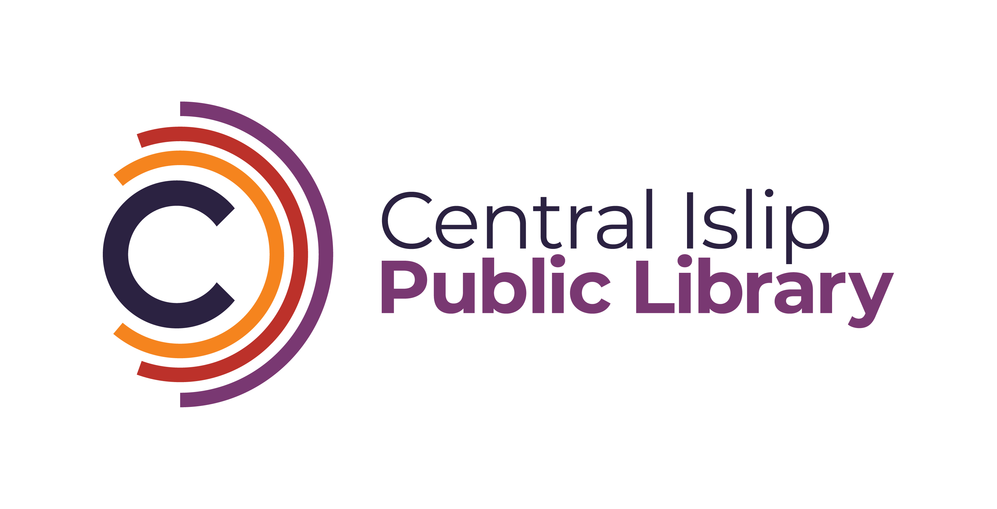

**33 Hawthorne Avenue, Central Islip, NY 11722 (631) 234-9333**

[**www.Cilibrary.org**](http://www.Cilibrary.org)

The Central Islip Public Library is seeking a motivated Reference Librarian or Reference Librarian Trainee to assist patrons with library resources and information across various formats. Strong communication skills, a commitment to excellent customer service, and a passion for lifelong learning are essential. This role offers an opportunity to contribute to library services, outreach, and programming for adult patrons.

**Qualifications:**

* **Reference Librarian:** Master’s degree in Library Science (MLS/MLIS) and New York State Public Librarians Certification required.
* **Reference Librarian Trainee:** Currently enrolled in an accredited Library Science Program.
* Experience in reference services is a plus.
* Bilingual candidates are encouraged to apply.

**Key Responsibilities:**

* **Community Outreach:** Represent the library at local events, collaborate with community organizations, and promote library services to adult populations.
* **Technology Assistance:** Assist patrons with computers, copiers, mobile printing, eBooks, databases, and other basic library-related technologies.
* **Promotional Content:** Create eye-catching displays and flyers to promote library programs, services, and resources.
* **Digital Content:** Ensure accurate and timely updates to the library’s website, and social media platforms related to adult services.

**Days and Hours:**

Tuesdays, Wednesdays, and Thursdays 5:30pm-9:00pm

One Saturday a month 9am-5pm

One Sunday a month 1pm-5pm (time and half rate)

**Starting Salary:**

* **Librarian Trainee:** $24.97 per hour
* **Librarian I:** $26.65 per hour

**How to Apply:**

Interested applicants can email a cover letter and resume to:

**Katelyn Hara-Moss** Assistant Director  
[kharamoss@cilibrary.org](mailto:kharamoss@cilibrary.org)