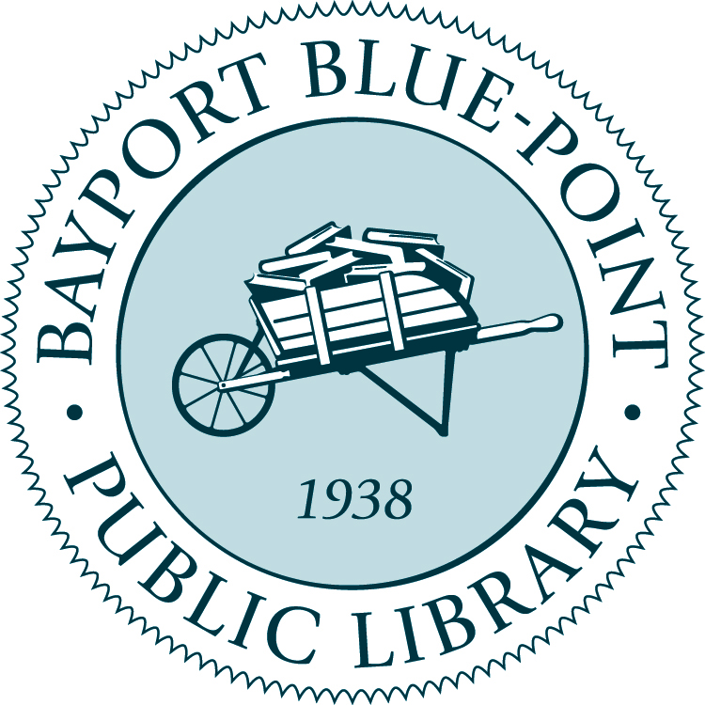
Children’s Services
Part-Time Librarian
10-15 hours per week. May include evenings and weekends.

Typical duties and responsibilities:

- Provide reference services and reader’s advisory to children, parents, and caregivers
- Develop and conduct programs for children from birth through grade 6, and parents/caregivers
- Create library displays, bibliographies, guides, and other materials that promote targeted services and/or collection subjects
- Ability to work as a team member and collaborate with coworkers on projects and programs
- Promote library services through community outreach to schools and local organizations
- Maintain awareness of trends in children’s services and issues affecting children
- Participate in collection development and maintenance
- Attend professional meetings & workshops; participate in staff projects
- Other duties as assigned

Qualifications:

MLS degree from an ALA accredited school and Public Librarian certificate or actively enrolled in an accredited MLS Program.

To be considered for this position please send a cover letter & resume
no later than December 2, 2024 to:

Emma Lodato, Head of Children’s Services
emma@bbplibrary.org
186 Middle Road
Blue Point, NY 11715
631-363-6133

The Bayport-Blue Point Public Library is an Equal Employment Opportunity Employer.

