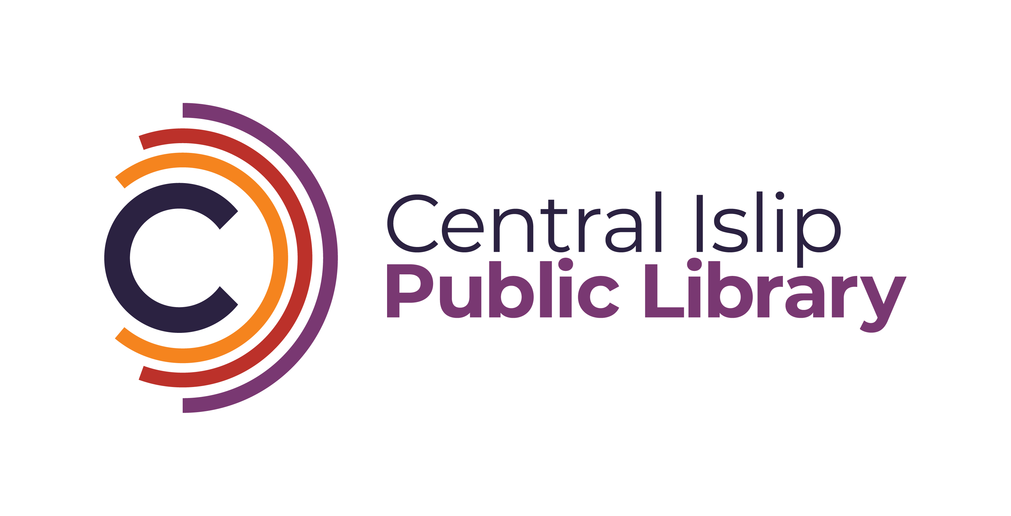

**33 Hawthorne Avenue, Central Islip, NY 11722 (631) 234-9333**

**www.Cilibrary.org**

The Central Islip Public Library is seeking a part-time Teen Librarian or Librarian Trainee to join our growing and busy Teen Services Department. The ideal candidate will enjoy running fun and inclusive programs, work well with fellow staff and the public, and have knowledge of current trends and literature of today’s Teens.

**Qualifications:**

* Master’s degree in Library Science (MLS/MLIS) preferred
* Enrolled in an accredited Library Science Program
* Experience in Teen Services is a plus
* Experience in 3D printing and podcasting is a plus
* Bilingual is a plus

Under the supervision of the Head of Reference Services, the part-time Teen Librarian Trainee will be responsible for the following:

* Assist with teen volunteer information and record management.
* Contribute to the creation of engaging content for social media platforms, including the Library website, Facebook, Instagram, and TikTok.
* Develop and implement programs tailored for teens that align with the library’s mission and goals.
* Perform other duties as assigned to support the Teen Services Department.

**Qualifications**:

* Currently enrolled in an accredited Library Science program (MLS/MLIS).
* Experience working with teens in a library or educational setting preferred.
* Strong communication and organizational skills.
* Proficiency with social media platforms and creative content creation.
* Ability to work independently and collaboratively as part of a team.

**Days and Hours Requirements:**

* Tuesday & Wednesday Evenings: 1:00PM-9:00PM/ 5:00PM-9:00PM or 5:30PM-9:00PM
* Friday afternoons as needed 1:00PM – 5:00PM
* One-two Saturdays a month 1:00PM-5:00PM
* One-two Sundays a month 1:00PM-5:00PM (shifts are time-and-a-half)

**Starting Salary:**

Librarian Trainee $24.97

Librarian I $26.65 per hour

**Interested applicants can email a cover letter and resume to:**

Katelyn Hara-Moss

Assistant Director   
Kharamoss@cilibrary.org