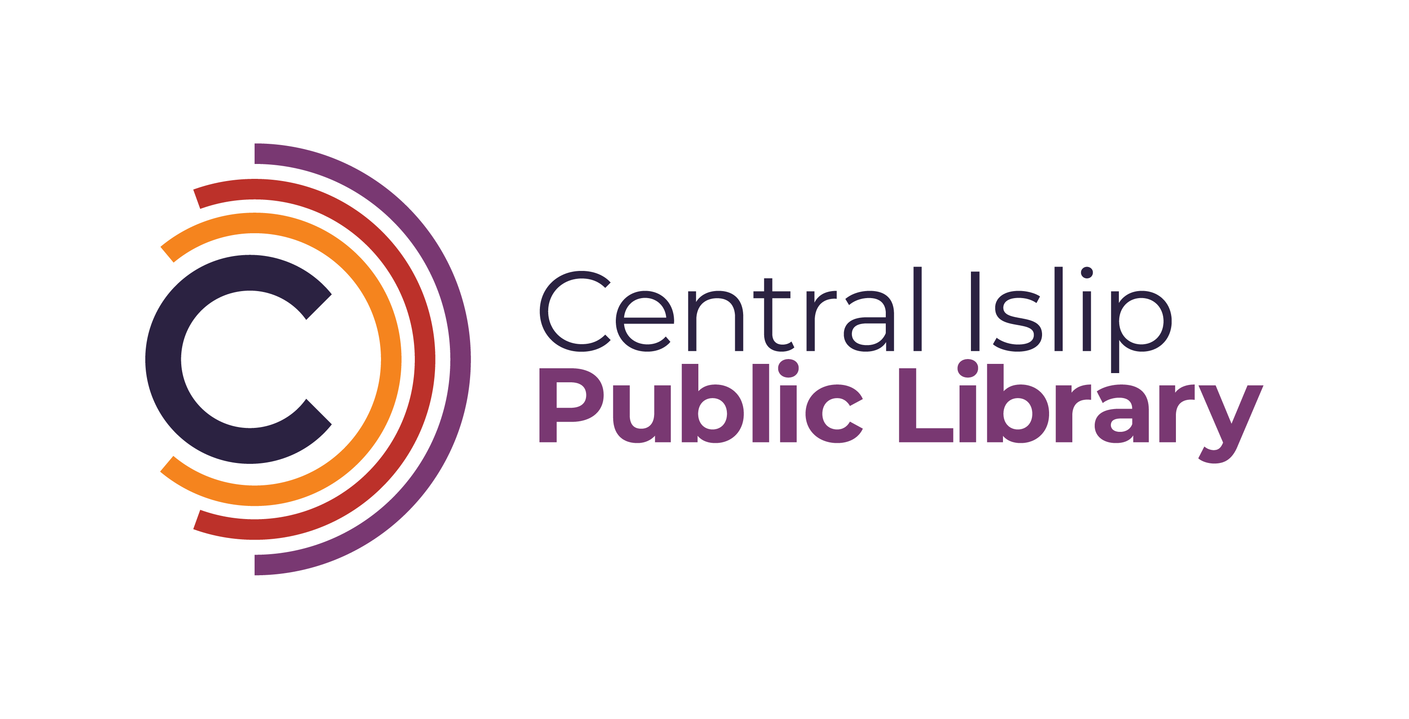

**33 Hawthorne Avenue, Central Islip, NY 11722 (631) 234-9333**

[**www.Cilibrary.org**](http://www.Cilibrary.org)

The Central Islip Public Library is seeking a knowledgeable and enthusiastic Reference Librarian or Reference Librarian Trainee to join our team. In this public-facing role, you will assist patrons in navigating library resources and finding information across various formats. A commitment to excellent customer service, strong communication skills, and a passion for lifelong learning are essential.

**Qualifications:**

* Master’s degree in Library Science (MLS/MLIS) preferred
* Experience in reference services is a plus
* Familiarity with digital resources and databases
* Ability to work collaboratively and engage with the community
* Bilingual is a plus

**Responsibilities:**

* **Programming:** Develop and facilitate programs, workshops, and events.
* **Collection Development:** Identify and recommend materials for purchase, focusing on adult fiction, non-fiction, and reference resources.
* **Outreach:** Engage with the community to promote library services and resources, including collaborating with local organizations.
* **Technology Support:** Assist patrons with accessing and using library technology, including computers, e-readers, and online resources.
* **Professional Development:** Stay current with trends in library services and technologies through ongoing education and training.
* **Other Duties as Assigned**

**Days and Hours:**

* Monday & Wednesday: 9:30 AM – 1:00 PM
* Thursday 5:30PM-9:00PM / 6:00PM-9:00PM
* Friday: 9:30 AM – 1:00 PM / 9:30 AM – 5:00 PM
* One to two Saturdays a month: 9:30 AM – 5:00 PM / 9:00 AM – 1:00 PM / 1:00 PM – 5:00 PM
* One to two Sundays a month: 1:00 PM – 5:00 PM (shifts are time-and-a-half)

**Starting Salary:**

* Librarian Trainee: $24.97 per hour
* Librarian I: $26.65 per hour

**Interested applicants can email a cover letter and resume to:** Katelyn Hara-Moss, Head of Reference Services  
kharamoss@cilibrary.org