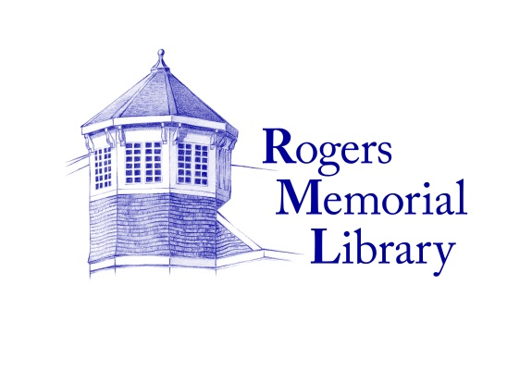

**P/T LEAVE REPLACMENT LIBRARIAN**

Rogers Memorial Library seeks a motivated and enthusiastic librarian or library trainee to provide coverage during a medical leave of absence.

**Job Description:**

Provide reference, research and readers’ advisory services

Assist patrons in the use of electronic and digital devices

Help library users find materials

Help public computer users with simple computer tasks

Assist with interlibrary loan requests

Able to work in Teen and Reference departments

**Required Qualifications:**

MLS from or currently attending an ALA-accredited library school

Knowledge of Sierra and Live-brary free downloads and databases

Work well with adults and teens

Able to conduct readers’ advisory with both adults and teens

Strong computer and communication skills

Commitment to proactive customer service

Bilingual a plus

**Hours:**

Average 21 hours per week.

Shifts can be weekdays, weeknights and weekends.

Position begins immediately and will last through the summer.

Hourly Rate: $25-$30 an hour depending on experience. Sunday hours paid double time.

Interested applicants should email a resume and two references to:

Beth Gates

Rogers Memorial Library

91 Coopers Farm Rd.

Southampton, NY 11968

beth@myrml.org