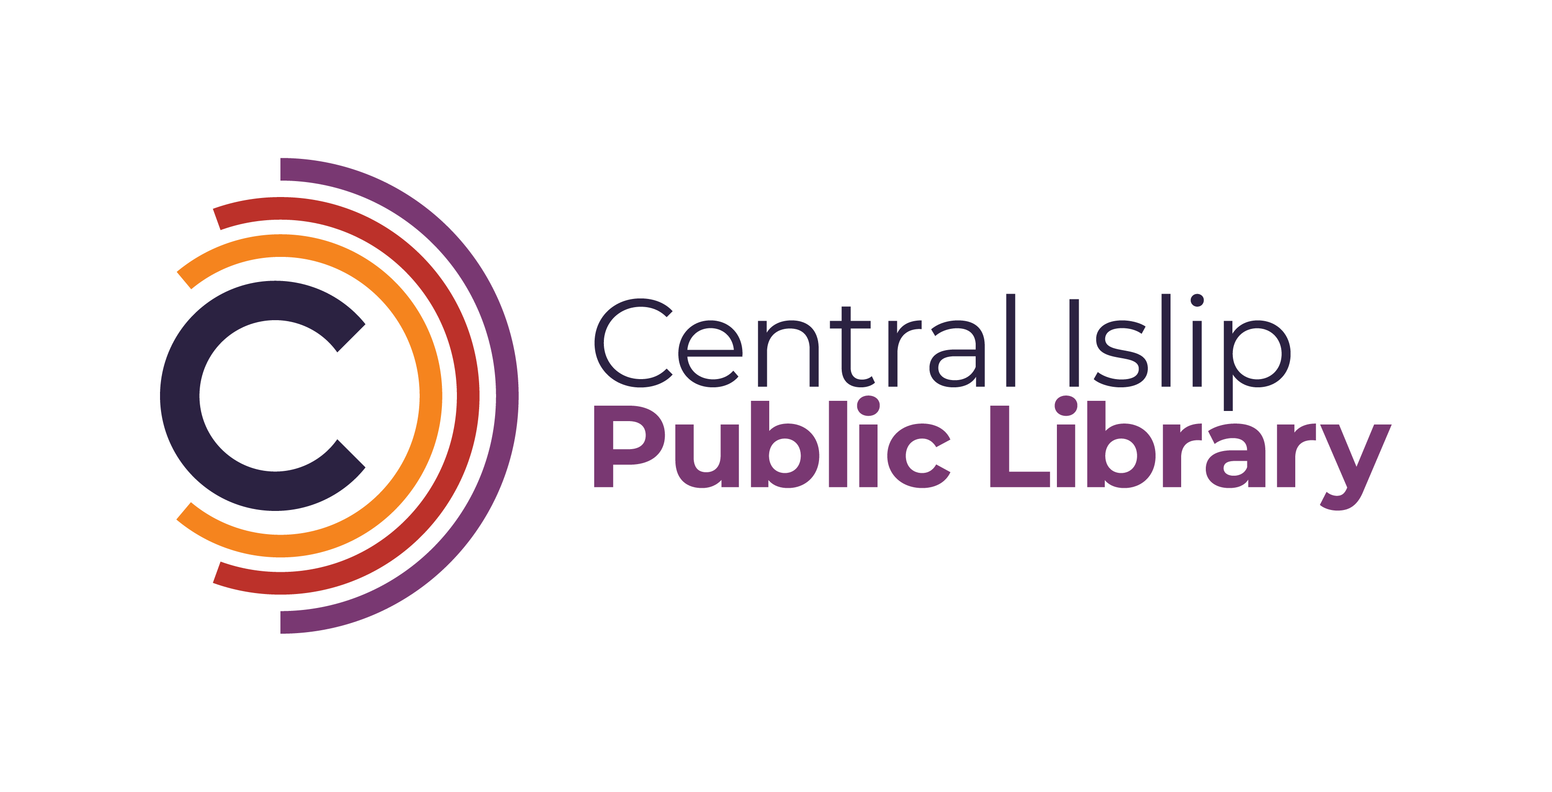

**33 Hawthorne Avenue, Central Islip, NY 11722 (631) 234-9333**

**www.CentralIslipLibrary.org**

The Central Islip Public Library in Suffolk County NY is seeking a part-time Teen Library Clerk to join our growing and busy Teen Services Department. The ideal candidate will enjoy working with teens in grades 7th – 12th, have knowledge of the latest trends, and have a positive attitude towards patrons and fellow staff members.

**Required Education**

* High School Diploma or GED

**Required Skills**

* Provide creative and friendly library service to teens in grades 7th- 12th
* Knowledge of computer technology, and hand-held devices.
* 3D printing experience a plus
* Bilingual a plus

**Responsibilities:** Under the supervision of the Head of Reference Services, the part-time Teen Library Clerk will be responsible for the following:

* Organizes library materials when requested, including filling and shelving
* Places library material holds, answers and transfers telephone calls, provides basic library information to callers, assists patrons with copy and fax machines

**Days and Hours Requirements:**

Tuesday & Thursday evenings

Fridays 1:00PM -5:00PM (as needed)

One Saturday 1:00PM-5:00PM a month

One Sunday 1:00PM – 5:00PM a month (Sundays are time and a half)

**Starting Salary:**

Library Clerk: $18.50

**Interested applicants can email a cover letter and resume to:**

Katelyn Hara-Moss, Head of Reference Services

**kharamoss@cilibrary.org**