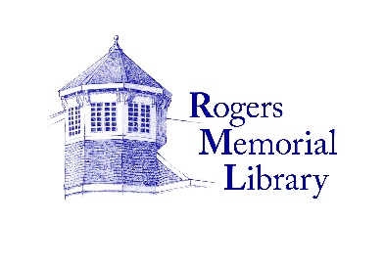

**Circulation Department Clerk**

Rogers Memorial Library is seeking an enthusiastic full-time library clerk to join its Circulation Department to assist patrons in a customer service driven atmosphere.

**Job Description:**

* Checking library materials in and out.
* Register patrons for library cards and updating accounts.
* Answers and routes telephone calls.
* Use cash register to collect payment for library materials.
* Calls to notify patrons when reserved materials become available.
* Performs various computer functions, assist with self-check out and public copier machines.
* Assists with other library tasks and projects as needed.

**Qualifications:** High School graduate or possession of a high school equivalency diploma.

* Fluency in speaking Spanish is a plus.
* Ability to work well with the public and excellent customer service skills.
* Strong communication and interpersonal skills.
* Ability to multitask with good clerical and computer skills
* Able to work a flexible schedule, reliable, team player.
* Willingness to learn new tasks in a changing environment.
* Knowledge of library OPAC, Sierra functions, library policies and procedures a plus
* Good physical condition to work in a fast-paced environment.

**Hours:** 35 hours/week. Requires occasional evening and weekend hours

**Compensation:**

Competitive salary plus medical insurance, retirement plan, paid vacation, sick, personal and holidays. Salary commensurate with experience.

**Contact:** Interested applicants should submit an application or resume by

**January 19, 2023** to:

Antoinette Walker, Head of Circulation

twalker@myrml.org