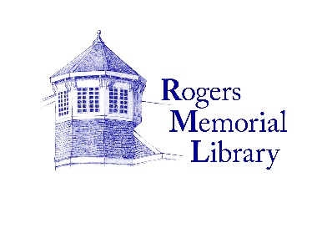

**Full-Time Adult Reference Librarian or Librarian Trainee**

Rogers Memorial Library seeks a full time Librarian or Librarian Trainee to join its Reference Department to provide excellent patron service.

**Job Description:**

* Provide proactive, personable general Reference research assistance and readers’ advisory
* Assist patrons in the use of electronic and digital services
* Process passport applications as a Passport Acceptance Agent
* Share responsibilities for collection development as well as weeding the collection
* Occasional programs and book discussions
* Maintain, expand and promote our special collections

**Qualifications:**

* MLIS from an ALA-accredited library school or currently enrolled in a program
* Strong computer and communication skills
* Commitment to proactive customer service
* Avid reader
* Bilingual a plus

**Hours:** 35 hours/week. Requires 1-2 evenings per week and rotating weekends.

*Salary commensurate with experience. Competitive benefits.*

Interested applicants should email a cover letter, resume and two references by

December 15, 2023 to:

Beth Gates, Head of Reference

beth@myrml.org