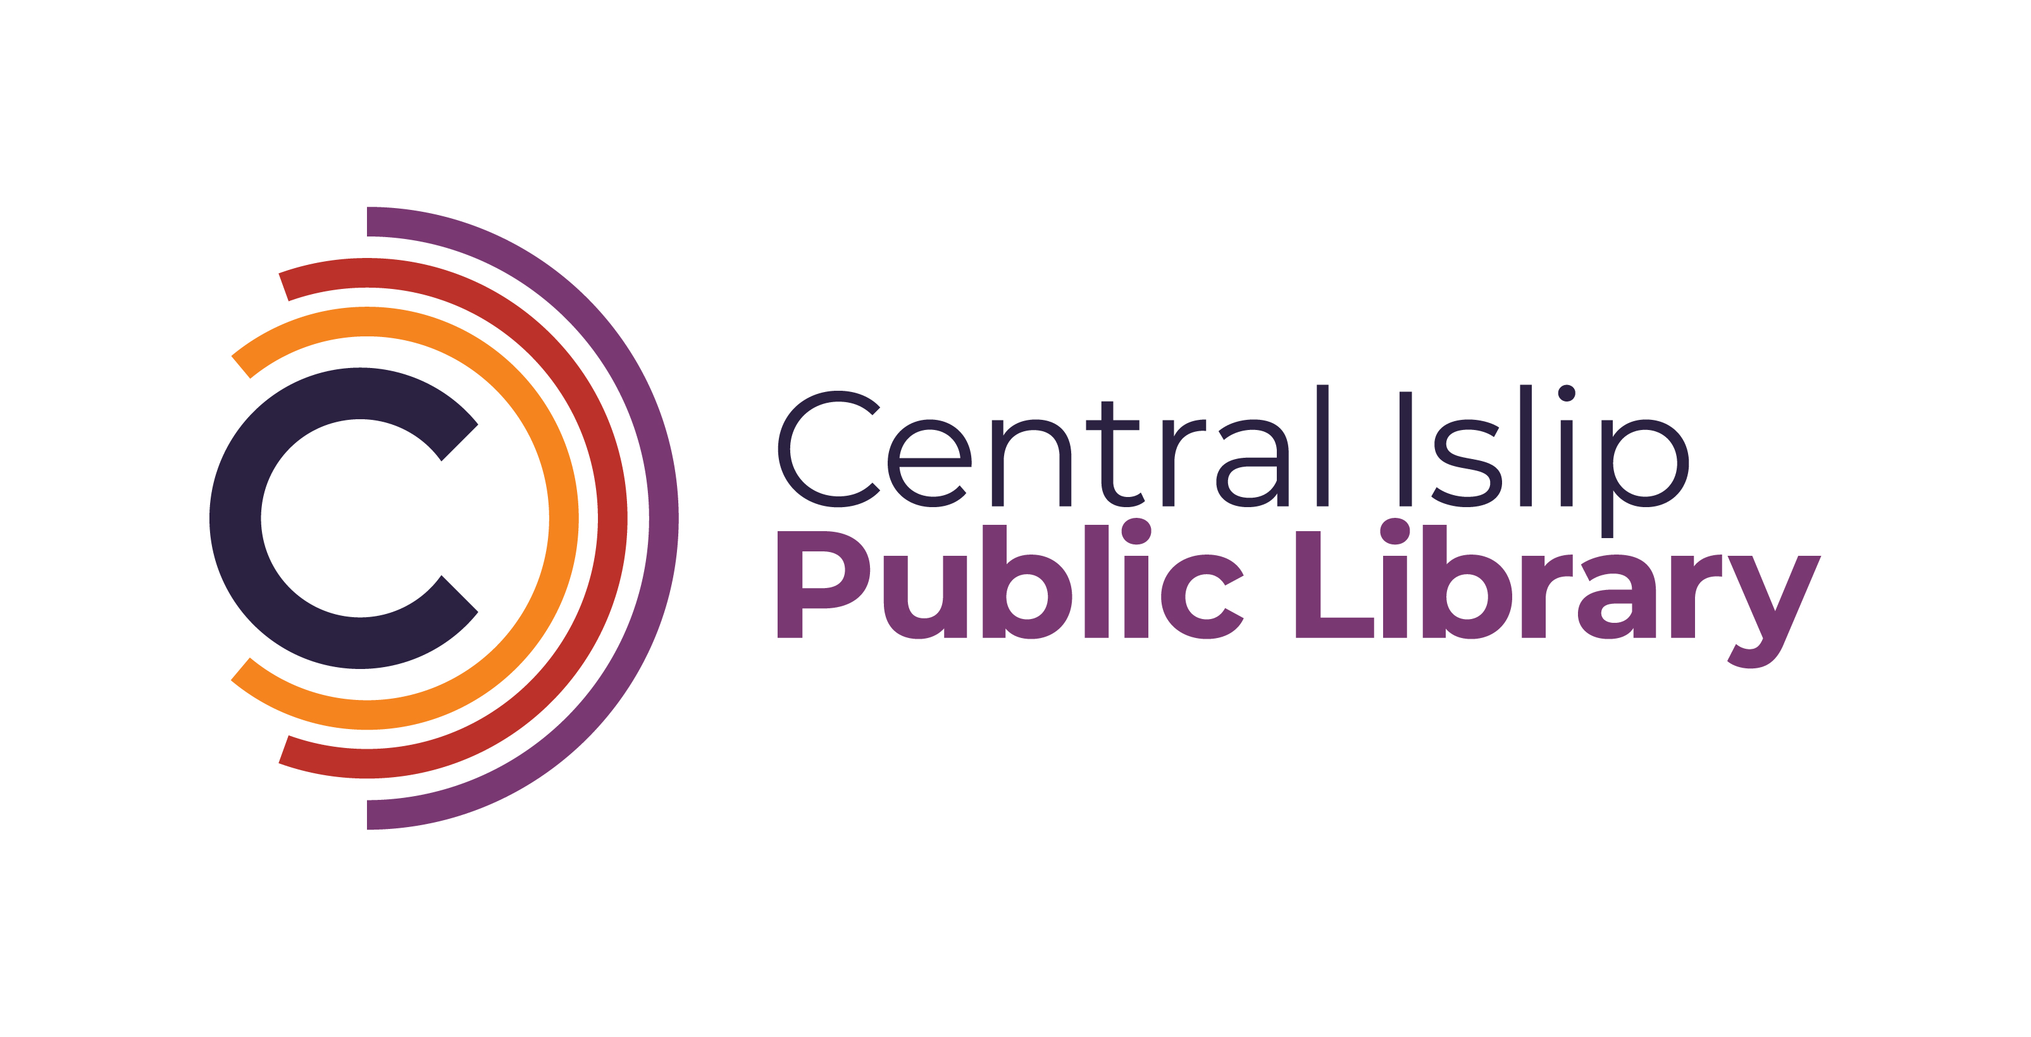

**33 Hawthorne Avenue, Central Islip, NY 11722 (631) 234-9333**

**www.Cilibrary.org**

The Central Islip Public Library in Suffolk County NY is seeking a part-time Teen Librarian I or Librarian Trainee to join our growing and busy Teen Services Department. Candidates are expected to assist patrons in locating books, other materials, and information both online and in print, reader’s advisory, digital services, preform collection development and run teen programs.

**Required Education**

* Currently enrolled or possess an ALA accredited Master’s degree in Library and Information Science
* Public Librarian’s Professional Certificate issued by the State of New York

**Required Skills**

* Strong commitment to public service and the ability to work well with a diverse patronage
* Strong organization and planning skills, including the ability to perform multiple projects or tasks simultaneously
* Demonstrated interpersonal, oral, and written communication skills
* Strong computer technology skills, including MS Word, Canva, Google applications, and e-reader devices.

**Responsibilities:** Under the supervision of the Head of Reference Services, the part-time Teen Librarian or Librarian Trainee will be responsible for the following:

* Maintains the layout and appearance of the Teen Department, ensuring a safe and inviting area filled with relevant resources.
* Develops and maintains content for social media platforms such as Library website, Facebook, Instagram, and Tiktok.
* Creates and implements appropriate teen programing
* Other duties as assigned

**Days and Hours Requirements:**

Must be available for evenings, one Saturday and one Sunday shift a month.

**Starting Salary:**

Librarian Trainee $24.97

Librarian I $26.65 per hour

**Interested applicants can email a cover letter and resume to:**

Katelyn Hara-Moss, Head of Reference Services

**kharamoss@cilibrary.org**