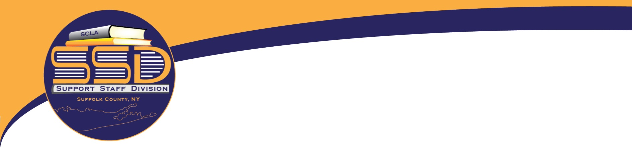­

Join SCLA’s  
Support Staff Division

**SSD…who are we?**

The Support Staff Division (SSD) is a division of the Suffolk County Library Association. It’s purpose is dedicated to all those library workers in the administrative, clerical, custodial, security fields and works to inform and educate its members on issues and information that pertains to their positions.

We strive to accomplish these goals by offering programs and roundtables such as out annual Safety Conference and opening lines of communications among members.

**SSD…what’s in it for me?**

Membership in SSD will enable you to…

Develop contacts with members throughout the county

Obtain opportunities to share ideas and resources

Attend programs that will help fine tune establish skills and develop new ones

Find fulfillment in your position

Increase your confidence

Exhibit a higher level of professionalism

Feel good about your contribution to your library

Members of SCLA and SSD are eligible for discounts on registration fees for many programs and events.

Visit SCLA online at [www.scla.net/membership](http://www.scla.net/membership)

And SSD at <https://sclassd.wordpress.com/>