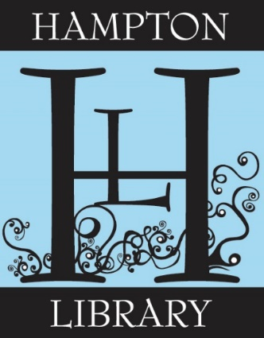

**Weekend / Substitute Adult Librarian or Librarian Trainee**

The Hampton Library in Bridgehampton is seeking a Librarian or Librarian Trainee for regular weekends as well as a substitute/call-in basis.

Qualifications and responsibilities include:

• Assisting patrons with Reader’s Advisory and computer support

• Excellent customer service skills

• Knowledge of Adult services or willing to assist in any department as needed.

• Embraces Teamwork

• Interest in running programs

• Available Saturdays, substitute hours, Sundays optional.

Requirements:

• MLS from an ALA accredited institution

• Valid NYS Public Librarian Certificate or currently enrolled in an accredited program

• Knowledge of Spanish a plus

Salary: Commensurate with education and experience or credits earned in a MLS program.

Please send resume and cover letter to [Employment@hamptonlibrary.org](mailto:Employment@hamptonlibrary.org) by 8/19/22.